Unit III
Writing news for Media
News writing is a straightforward type of writing that presents facts, events and other information to readers in an accurate manner. People may use news writing for newspapers, websites or broadcasting. Journalism or news writing is a prose style used for reporting in newspapers, radio, and television. When writing journalistically, one has to take into account not only one’s audience, but also the tone in which the piece is delivered, as well as the ABCs of news writing: Accuracy, Brevity, and Clarity.
The structure of news stories has changed over time, the overall purpose remains the same. News writing informs and entertains readers and listeners. News stories give citizens information about events happening both in their communities and around the world and therefore play an essential role in shaping their viewpoints and general ideas.
What is a lead?
A lead is an opening paragraph that gives the audience the most important information of the news story in a concise and clear manner, while still maintaining the readers’ interest. If a reader does not read beyond your first paragraph, they should still have an idea of what your article is about and the most important information from that article. There are many different strategies for writing a good lead as well as many differing opinions, but the strongest opinion is that they are hard and take time. Don’t plan on rushing a good lead.
Writing a Lead
The Five W’s and H. Before writing a lead, you need to ask the fundamental questions of newswriting; who, what, when, where, why, and how. Be sure to answer these questions in your lead and leave the less important information for later in your article. Remember the inverted pyramid.
Keep it Simple: The best lead is one that is concise and clear. Think about your story and then write a simple but powerful way to reflect it. Don’t bog your reader down with overly complicated language or extra words. You must be clear and concise.
Don’t bury your lead: Your lead is your hook (the thing that makes the reader interested in your story). If you bury it, then their interest might be buried along with it! They shouldn’t have to ask themselves what the story is about, you should be telling them upfront.
The ABCs of journalism: Remember your ABCs which are Accuracy, Brevity, and Clarity. Though these should be incorporated throughout your article, they are especially important in the lead.
Different Types of Leads
Summary Lead
A summary lead is the most common and traditional lead in journalism. It is meant to give a quick summary in as few words as possible and is usually one sentence. It contains most of the 5Ws (who, what, when, where, why) and the H (how).
A summary lead concisely tells the reader the main idea of the story or conveys its news value. Most journalists and editors believe that the lead should come in the first sentence or first few sentences of a hard news article.
Blind lead, the journalist sets a scene or tells a story without immediately making clear the Who or What of a story, in order to build tension, establish a tone, or pique audience interest.If the person concerned is not well known in the community, his/her name is less important than other salient facts that identify the person. E.g. “a 80-year-old woman” instead of her name. A police inspector’s son was attacked with a knife by some miscreants on Mount Road this evening.
Delayed Lead: Begins with an interesting example or anecdote that sets a story’s theme. Then- perhaps in the third or fourth paragraph- the “nut graph” summarizes the story and provides a transition to the body. Thus, the nut graph moves the story from a single example or anecdote to the general issue or problem.
Delayed Identification Lead: The “who” is not identified right away in this lead because it isn’t deemed as important (for example, a member on the school board punched the president). Instead a descriptive pronoun is used to describe the person and his title and specific name is revealed in a later paragraph.
Creative Lead: The purpose of the creative lead is to capture the interest of readers where a summary lead might not.
Short Sentence Lead: A short sentence lead uses one word or a short phrase as a teaser with the rest of the lead appearing later. This is often considered gimmicky, so only use it now and then.
Analogy Lead: This lead makes a comparison between and issue or event and something else a reader may be more familiar with.
Single-Item Lead: This lead focuses on just one or two elements of a summary lead. The purpose is to pack a bigger punch than a summary lead.

The credit line: a line of text acknowledging the source or origin of published or exhibited material. Also called credit limit, line of credit. It includes information such as name, publication, and date. The journalist’s name is typically their last name, first and last. This can also include their initials if they have not yet been given a byline or if it’s not clear who wrote the article.
A credit line is a form of journalistic acknowledgment of the source of origin. It is a kind of attribution that gives credit to the person or entity that has provided information. It typically refers to the line of text at the bottom of an article. It is usually a shortened version of "byline." When journalists write articles, they are given credit for their work in a credit line. Though there are many different credit lines, they will often be at the end or beginning of an article.
Acknowledgment is the act of acknowledging the existence or role of someone or something. It can be a form of expression that shows gratitude, respect, or support. Acknowledgment is often used in journalism and other fields to show that someone has been heard and considered their opinion. The acknowledgment section is an important part of any article, especially for journalists writing about people who have not made it into the headline. It allows them to give a voice to those who may not have had one in the first place.
Byline tells the reader who wrote the story. On short, un-bylined stories (routine speeches, game stories, announcements, etc.), the dateline generally should reflect where the story took place. Typically bylines will just show the date and author's name. In the spirit of keeping things short and sweet, Mike Spohr cleverly uses only a few words to tell you who he is, what he does, and something to remember him by.
Bylines give credit to writers, and if you’re writing for a newspaper, your byline signals that you’ve crossed into professional journalism. Bylines also position writers as subject matter experts or authority on specific topics or target audiences. In simple terms, a byline is an article where you are the author, and where your name will appear clearly as the author of the piece. This is media-speak for the name attached to a particular article. It literally means ‘by so-and-so.
Byline: name of author of story. (Different from credit line, which is the name of the photographer.) Byline means that person wrote the story. The other credit lines mean they contributed information which the writer used to craft the story.
News is information about current events. This may be provided through many different media: word of mouth, printing, postal systems, broadcasting, electronic communication, or through the testimony of observers and witnesses to events.
News is that part of communication that keeps us informed of the changing events, issues, and characters in the world outside. Though it may be interesting or even entertaining, the foremost value of news is as a utility to empower the informed.
NEWS stands for North, East, West, and South. It is a term used to describe the information or reports about current events or happenings from all four directions of the world. It all started in the 14th century, when the English word 'news' developed as a special use of the plural form of 'new'. As the name implies, 'news' is associated with the presentation of new information.
News style, journalistic style, or news-writing style is the prose style used for news reporting in media such as newspapers, radio and television.
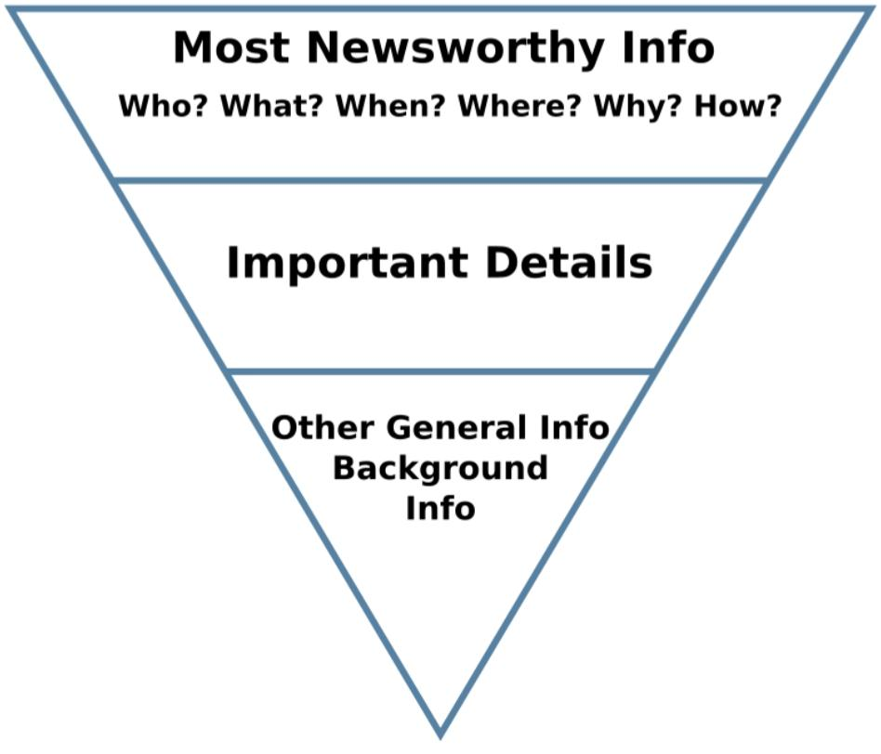
News writing attempts to answer all the basic questions about any particular event—who, what, when, where and why (the Five Ws) and also often how—at the opening of the article. This form of structure is sometimes called the "inverted pyramid", to refer to the decreasing importance of information in subsequent paragraphs.
News stories also contain at least one of the following important characteristics relative to the intended audience: proximity, prominence, timeliness, human interest, oddity, or consequence.
Techniques:Journalistsobtain information through a variety of reporting techniques, which can include interviewing sources, looking through government documents, researching old articles, and observing events firsthand. Good news writing begins with good, accurate reporting.

- Organization (the Inverted Pyramid)
- Lead
- Fact (Not Opinion) and Attribution
- Identification: full first name or both initials
- Short Paragraphs: for punchiness and appearance.
- Person: third person
- Headlines: short and preferably snappy. No articles used
Accuracy in journalism is an important ethical guideline. Accuracy is different than the truth. Truth in journalism is important and means that a report is based on facts. But accuracy means that a journalist has the responsibility to check to see whether or not the facts are true or not.News accuracy is broadly defined here as truthful reproduction of an event or activity of public interest. An inaccuracy is a flaw in the reproduction.
The readers should never be given an opportunity to say that they never believed what appeared in the papers. All facts given in the news item should be accepted by readers without questions.
The term accuracy not only means checking that the text is factually and grammatically correct, but also that the text confirms to all the style guidelines. Four steps should be kept in mind while ensuring that accuracy is maintained in professional writing: Keep a sharp eye on factual errors, style inconsistencies, misspellings, or grammatical mistakes while writing any piece of communication.

News format:
News articles follow an Inverted Pyramid format. The lead, or main points of the article—the who, what, when, where, why and how of a story—are placed at the top or beginning of the article. Additional information follows the lead and less important, but still relevant information, comes after that.
- Introduction of the Report.
- Body of the Report.
- Answering the 5Ws and the H.
- Writing in Short Sentences.
- Attribution.
- Factual Check.
- Concluding the News Report.
- Catchy Headline.
The newspaper structure can be broken down into four key sections which includes the headline, byline, the lead, the body, and the tail.
Rewriting literally means to write again to check the formats, placements, facts and figures.Editing involves correction of news stories by checking its grammatical errors, spellings, punctuations, etc. But sometimes the errors are so serious that they require the story to be rewritten. Rewriting is done because the original copy of news story has serious flaws in formats, organization or accuracy.
Rewriting allows us to explore endless creative writing ideas. It gives you the chance to explore different options and alternative possibilities for your writing. It’s a process all about experimenting and playing with possibilities.
Rewriting is nothing but re-telling the same story once which has been already told. There are two methods of rewriting: simple (technical), which is carried out through replacement of words in the text with their synonyms and transfer of text parts; complex (deep) rewriting, which is done for more demanding news agencies and publications, it is close to copywriting.
The need to rewrite a news report arises when the story lacks a clear structure. There is no clear lead; and there is no clear arrangement of facts. You feel baffled and lost when you read the story. Your first step should be to identify the main news point.
Rewriting means to rewrite or change more than 60% of a document's text. Rewriting may also dictate reforming paragraphs, deleting paragraphs of re-arranging paragraphs to improve flow and continuity. It is almost as extensive as writing itself.

Sports journalism focuses on reporting amateur and professional sporting news and events. Sports journalists work in all media, including print, television broadcasting and the internet. If you are a sports fan and would like to pursue journalism, read on to find out what you can do as a sports journalist.
The following are the five most common types of sports stories: 1. Straight-Lead Game Story The most basic form of all sportswriting, the straight-lead (also spelled straight-lede) game story is an article using a straight-news format.
Sports writing is a form of creative nonfiction or journalism that covers sports, athletes, or other sports-related issues. A journalist who reports on sports is called a sportswriter.

What Are the Elements of Sports Writing?
Sports writing typically covers basic information, such as:
- highlights of the game
- the names of the teams involved
- the type of sport
- score or final outcome
- when and where the game was played
But in order to write a good sports article, remember to focus on what an athlete does. Because sports revolve around the drama of competition, spotlighting a single person gives your story a human side that your readers can relate to.

5 Types of Sports Stories

1. Straight-Lead Game Story
The most basic form of all sportswriting, the straight-lead (also spelled straight-lede) game story is an article using a straight-news format. The article summarizes the main points of a game: which team won or lost, the final score, and what a star player did.
A straight-lead might look something like this:
Second-string quarterback Robert Jameson threw the game-winning touchdown with just 10 seconds left to lead the Mountain View High School Bears to a 21-14 victory over the Canyon del Oro High School Captains Saturday night.
After that, the story follows by giving an account of big plays, players who contributed tremendously to the final outcome, and after-game insights, quoting both players and coaches.
Many high school and college sports use the straight-lead game story, but sports writers for professional sports events have veered away from this format.
The reason is that TV already shows the entire game and fans usually know the scores and highlights before the article makes it to publication.

2. Feature Game Story
The feature game story is a favorite tool for professional sports writers because it gives fans and readers a different angle from the highlights they have seen on TV.
Here’s an example of an actual sports feature lead involving the Queensland Reds and their rugby coach, Tevita Koloi:
It’s the start of yet another season. The quiet of the night contrasts with the vibrant group gathered in the upper room of their local church, fervently praying. As the clock ticks closer towards midnight, the spiritual coach of the state’s professional rugby team receives an impression from God – “the last placed team he is mentoring will win the entire league this very year.”
It is a bold revelation, and he grapples with what to do with this.
After opening with this unique angle, the writer proceeds to describe the prominent rugby coach’s background, as well as what was going on at the time he had this unusual experience.
And, as is common trait of feature game stories, he only gets to the scores near the end of the article—which is fine because readers are not looking to read about the score, which they already know.
Instead, the story gives them a different perspective of the game and the people involved.

3. Profiles
Whereas a feature game story spotlights a game, a profile features an individual character. This person might be a rookie athlete rising in the ranks, or perhaps an influential coach.
To show you the difference between a feature game story and a profile, here is an example of a real-life personality profile opening of the same rugby coach Tevita Koloi:
He stood on the bridge, pondering how everything in his life had gone wrong. After several years of depression, disappointment, abuse and separation, he had reached the end of his rope and was ready to end it all. He closed his eyes, readying himself to take this irreversible step. At that very moment, he heard a seemingly innocuous noise from below, “Beep-beep! Beep-beep!” He opened his eyes and reached into his pocket for his phone, intending to read this message before he went forward with his tragic plan. The words he read, sent from an acquaintance he was not even particularly close to, shocked him out of his stupor: “Jesus loves you. He will never leave you. Receive His love.”
The story then proceeds to describe his battle with depression and suicide, and how he used the same thing that saved him, text messaging, to help others in the sports world.

4. Season Preview and Wrap-up Stories
Every sportswriter needs season previews and wrap-up stories in their collection. These stories are published while the coaches and their teams are preparing for the upcoming season, or after the season has ended—whether in victory or in defeat.
These stories take a bird’s eye view of the season: they normally share the expectations that coaches and players have, or how they feel at the end of a season.
A fictional example of a lead for this kind of story is:
Coach Sandy Miller has high hopes for the Bannerview High School women’s volleyball team this year. With the Royals being the county champions last year, led by dynamic team captain Serena Delgado, who continues to lead the team this year as a senior. “We believe she’ll bring the team to greater heights this year,” Coach Miller says.

5. Columns
A sportswriting column is the place where a sportswriter shares their opinion. Sometimes these columns may include venting when a team, player, or coach doesn’t meet expectations. Other times, they may write about what they admire in a team, player or coach.
A favorite subject is a coach who is able to direct a weak team to an unexpected championship, or perhaps an underdog player who demonstrates unusual determination and teamwork.
Here is an excerpt of a column from The Sports Column:
For me, head-to-head competition is the most significant indicator for seeding, but not to EIWA coaches.
When coaches use rules/regulations to protect their interests, then athletes suffer. To make a three-time All-American–a proven wrestler–a 4-seed behind an opponent he has defeated…well…that’s bad for everybody. And to make things worse, the only other seeded wrestler who has qualified for the Nationals (Jared Prince of Navy), is seeded #5, opposite Kolodzik. None of the other six seeds have had such success this year.

Sports organisation means the International Olympic Committee, all international federations, national Olympic committees, and their respective members at the continental, regional and national- level, as well as any other organisations recognised by the International Olympic Committee. Sports organisation means any NSO that is a Member of PNZ.
The differences we identify between them suggest a possible classification into three types: sport governing bodies, sport event organizations and sport providing entities.

